

Senior Design
ENG EC 464
Boston University Electrical & Computer Engineering
The Triton Final Testing Report

Team 25

Required Materials

Hardware:
- Raspberry Pi 3B
- USB-A to Micro cable
- 3x 5V Rechargeable Battery
- OAK-D S2
- iPhone
- Lightning to USB-C cable
- Mac
- StereoPi Slim V2
- PETG Filament
- Flex Seal
- Anemometer
- Adafruit Flora GPS Module

Software:
- Bluetooth Python Script
  - Connect the Triton (Raspberry Pi) to the iOS application
  - Read from:
    - The OAK-D and send a photo, distance data, and object detection data
    - GPS data such as speed over ground, longitude and latitude, and course over ground
    - Distance values from the StereoPi cameras
    - Wind speed and direction from the anemometer
- Camera Distance Recognition and Object Tracking Python Script
  - Determine if an object is present and present its distance and angle
  - Visualizes if an object is within a certain distance relative to the camera
  - Track a given target to give more detailed distance information
  - Provide a detailed heat mapping to find the closest object within a set distance
- iOS Application
  - Showcase the data collected from the various modules connected via Bluetooth
  - Present polar mapping display of detected objects and depths near the boat
  - Demonstrate an improved UI with partitioned information on different pages
- StereoPi Software
  - Use depth mapping to determine the distance of an object from the cameras
  - Convert the camera-based distance values to meters for an accurate representation
- Anemometer Software
  - Collect wind speed and wind direction data and send it over Bluetooth via DBus
- GPS Software
  - Record, parse, and pass to Bluetooth via DBus
Setup

This demonstration will show the complete architecture of our product’s design with each module individually completed and integrated into the iOS application through its Bluetooth connection. These modules include the OAK-D camera, StereoPi cameras, anemometer, GPS, and iPhone application.

Pre-Testing Setup:

Raspberry Pi
- Flash the Raspberry Pi 3b’s SD card with the Raspberry Pi OS 64-bit image
- Clone our git repository onto the pi
- Activate our virtual environment
- Open the /Senior-Design-Sailboat-Nav-2025/RPI-BLUETOOTH/ folder
- Run the bluetooth.py script (python3 bluetooth.py)

OAK-D
- Install depthai and the necessary dependencies
- Plug into Raspberry Pi/Laptop
- Activate our virtual environment
- Open the /Senior-Design-Sailboat-Nav-2025/OAK-D/ folder
- Run the script (Triton.py)

StereoPi
- Install picamera v.2s into ports
- Install Rasbian Debian 32-bit Legacy Edition onto an SD card
- Move PiCamera open source file folder onto the SD card
- Boot up PiCamera and install StereoVision and OpenCV via PiP
- Move the stereopi directory into a local directory in the Pi
- Run the 2_chess_cycle to calibrate cameras
- Run the 3_pairs_cut to pair up the calibration photos
- Run the 4_calibration.py file to properly calibrate cameras.
- Run the 5_dm_tune file to calibrate the cameras
- Run the 6_dm_video file to ensure correct disparity mapping
- Run the 7_2d_map file to measure distance.

iPhone/Mac
- Download XCode
- Clone git repository
- Open the /Senior-Design-Sailboat-Nav-2025/Triton/ folder in XCode
- Connect iPhone to Mac via USB-C cable
- Put iPhone in Developer Mode
- Make sure that the app signature is a trusted developer in the iPhone running the app
- Press the play button in the top left corner of XCode

Housing/Prints
- Create the housing design
- Print the STL files using PETG filament
- Spray and cure prints with flex seal

GPS
- Enter the Raspberry Pi configuration
- Select “Interface Options”
- Select “I6 Serial Port”
- Disable the login shell
- Enable the serial interface

Anemometer
- Enter the Raspberry Pi configuration
- Select “Interface Options”
- Select “I2C”
- Enable I2C
- Connect the anemometer to the Raspberry Pi and ADC via the RJ-11 coupler and cable
- Calibrate the wind direction

Testing Procedure

Circuit Diagram
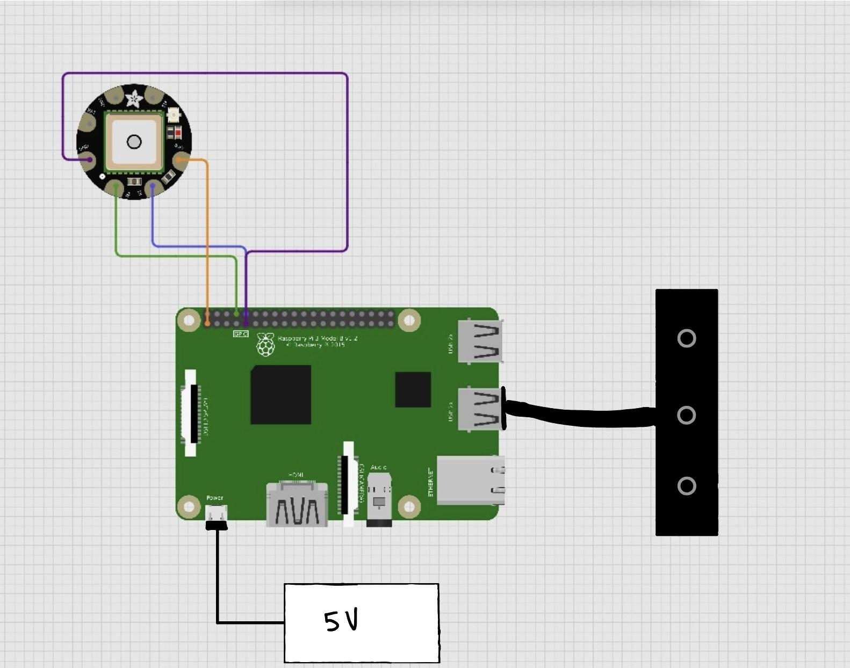
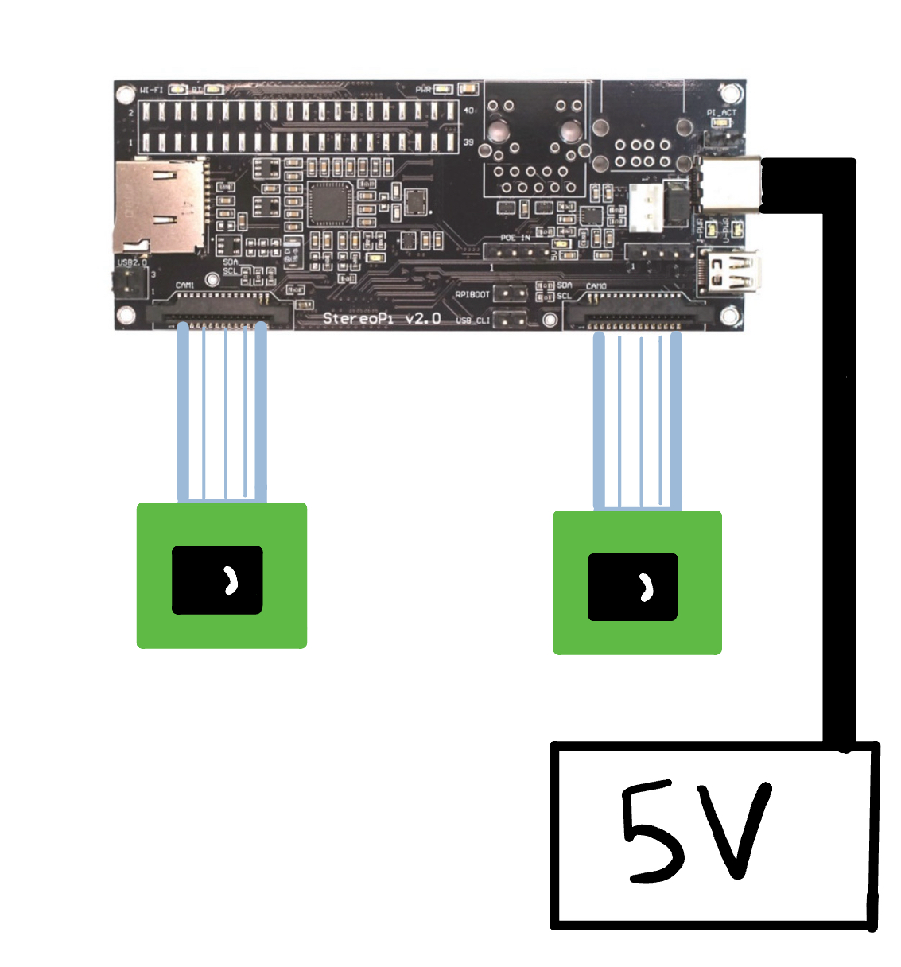
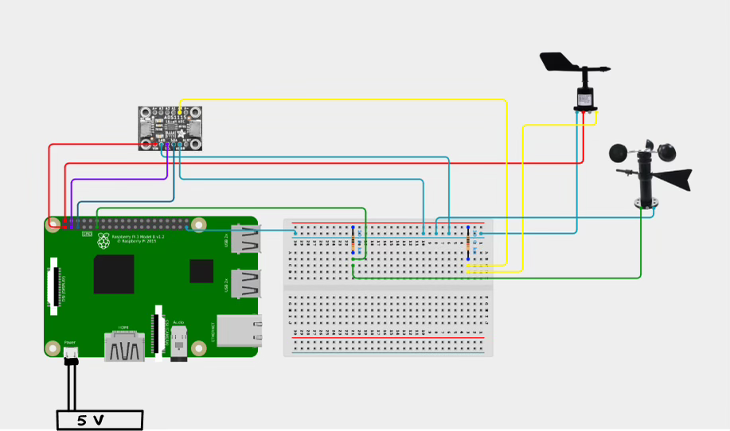

Hardware Pinout
Raspberry Pi | Peripheral
Pin 1, 3.3V | GPS 3.3V
Pin 9, GND | GPS GND
Pin 8, TX | GPS RX
Pin 10, RX | GPS TX
USB Port | OAK-D
Anemometer Data | Anemometer A0
GND Rail, Breadboard | Anemometer ADDR
Pin 3, SDA1 | Anemometer SDA
Pin 11 | Anemometer SCL
GND Rail, Breadboard | Anemometer GND
Power Rail, Breadboard | Anemometer VIN

OAK-D Camera:
- Run the Python script for object tracking (python Triton.py)
- Place the camera on a moveable object (desk chair)
- Place someone in front of the camera from a set distance to simulate a boat’s presence
- Have them slowly approach the camera
- Have them step back and then slowly move to the left or right
- The live feed on the monitor will place an outline around the person and show their distance and angle from the camera while also showing a depth reading for their distance
- Have the person slowly walk away from the camera and observe as the warnings on the monitor go away
- Move the camera around the room to show the changing depths of the environment
- Play the video showcasing actual boat recognition capabilities of the camera

StereoPi:
- Run script for depth mapping (7_)
- Hold the cameras in such a position where they are pointing at the same direction
- Place an object at a fixed distance
- Move the object slowly towards the camera
- Showcase the adjusting colors of the depth map to indicate an object approaching

iOS Application:
- Plug in Triton and StereoPi
  - Run the Oak-D python script, Anemometer python script, GPS C++ script, and Triton Bluetooth script (all will initiate on boot)
  - Run the StereoPi depth mapping script and StereoPi Bluetooth script
- Establish the Bluetooth connection to the Triton and StereoPi1
- Showcase the organized tabs of the application with data from each module
- Show the images from the OAK-D appearing on the application
- Show the polar rendering of the depth data collected from the OAK-D and StereoPis
- Show a representation of boats on the rendering while in the frame of the OAK-D (a person will substitute a boat for this testing)

Anemometer:
- Take the anemometer outside to get wind data
- Observe the direction of the wind being recorded within the iOS application

GPS:
- Take the GPS outside to get a fix, and wait until the GPS module stops blinking every second
- The iOS application will auto-connect to the Triton (Raspberry Pi)
- Observe the data collected as it is displayed in the iOS application

Housing/Prints:
- Showcase the design and print style of the main housing
- Explain the choices made in the printing design
- Demonstrate the properly sized and fitted holes for the modules that will be placed within our connected to the housing
- Describe waterproofing techniques used and and considered (printing style, filament type, etc.)
- Show the OAK-D mount with a perfect-fit slot
- Showcase the design and housing for the StereoPi cameras
- Repeat steps 2 - 4
- Show the properly spaced and aligned holes for the cameras to produce accurate readings based on their calibration

Measurable Criteria
- The OAK-D camera will show a live view with an ROI (region of interest) around a detected object to showcase the distance of detected objects on the Raspberry Pi through a monitor
- The OAK-D camera will print the relevant ROI and object detected, and if the object is too close and location relative to the camera on the Raspberry Pi
- The StereoPi cameras will be able to detect objects coming close to the camera
- The iOS app will connect to the Raspberry Pi
- The iOS app will showcase a polar map rendering of the depths and boats detected by the cameras with live updates
- The application will receive the transmitted image taken from the OAK-D
- The application will connect to the Anemometer, OAK-D, and StereoPi and display their relevant data
- The main housing will be printed with properly sized holes for battery packs, clamps, and the OAK-D
- The StereoPi housing will be printed with properly sized holes for the battery packs and properly spaced holes for the camera alignment
- The GPS should receive a signal (fix) outside and record relevant information
- The GPS will get data and transmit via DBus
  - This includes: UTC Time, Longitude, Longitude Indicator, Latitude, Latitude Indicator, and Altitude
- The anemometer will register wind-based data as the modules move and prepare the relevant data to be sent to the iPhone via Bluetooth

Score Sheet

Task | Completion (Y/N)
OAK-D displays a live feed | Y
OAK-D has a box outline around the tracked object/person | Y
OAK-D prints out a message that an object is too close with its distance accurate within 0.5m | Y
OAK-D shows a heat map of depth-based distances | Y
OAK-D image is uploaded and visible on the iOS app | Y
StereoPi showcases a depth mapping | Y
iPhone is able to detect and connect to the pi | Y
Polar rendering is loaded on the app with live updates of points as depth values change | Y
Application displays other module information | Y
Enclosure is printed with fitted holes | Y
Clamps fit in the enclosure | Y
Anemometer should send wind direction from outside | Y

Conclusions

This final testing aims to show the near end-to-end development of our project over the course of the year. We have been building off of each prototype and redefining our goals while also refining our modules to perform their tasks as efficiently as possible in order to ensure a smooth and helpful docking experience. OAK-D added new logic to better represent distance data while the StereoPi cameras refined their calibrations to be more accurate. We completed the implementation of the anemometer and were able to transmit the relevant data, thus completing our final module to be developed. The housing design was finalized with final prints being completed for open field testing. The iOS application was adjusted to handle all communication and data while also redesigning the rendering from the last prototype to be as visually clear and accurate as possible. Some software updates may still occur as feedback is given and more testing is done, however a major achievement was the completion of our hardware development. In this final month we aim to perfect the system as best we can with the modules and architecture we have designed for a complete docking assistant system to be used on open water.

